Setting up a Discussion Forum

First of all - there is more than one forum type from which you can choose:

- A single simple discussion - A single topic discussion developed on one page, which is useful for short focused discussions
- Standard forum for general use - An open forum where anyone can start a new topic at any time; this is the best general-purpose forum
- Each person posts one discussion - Each person can post exactly one new discussion topic (everyone can reply to them though); this is useful when you want each student to start a discussion about, say, their reflections on the week's topic, and everyone else responds to these
- Q and A Forum - Instead of initiating discussions participants pose a question in the initial post of a discussion. Students may reply with an answer, but they will not see the replies of other Students to the question in that discussion until they have themselves replied to the same discussion.
- Standard forum displayed in a blog-like format

Once you have decided which one you want - the rest is easy!

1 - go into your course and Turn Editing on

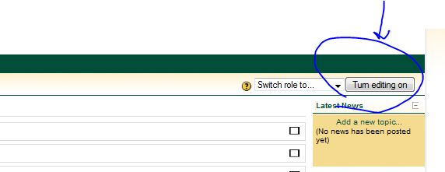

2 - in any Topic, from the menu "Add an activity ..." choose "Forum"

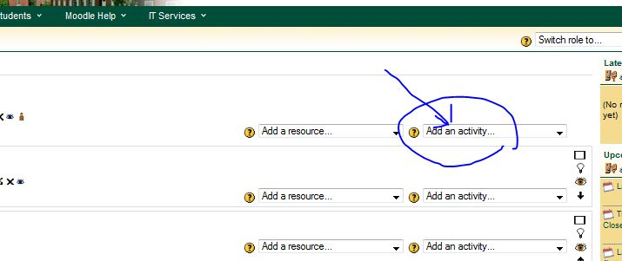

3 - Give it a specific Forum name (A) - maybe something like "Post Paper One on the Conrad Black here" or "Here we will discuss the Historical Aspects of the 3rd Century"

4 - if you want them all to post one time and only one for this Topic, then for the Forum type choose "Each person gets one discussion"

5 - In the big box - give the specific directions you want to give them - some thing like _ "In this place you each get one chance (and one chance only) to post your paper on the Conrad Black. After you post it, your classmates will be able to read it" Where it asks for a "Subject" - start this line with your name first! Put them in (B)

For now leave everything else below alone (C).

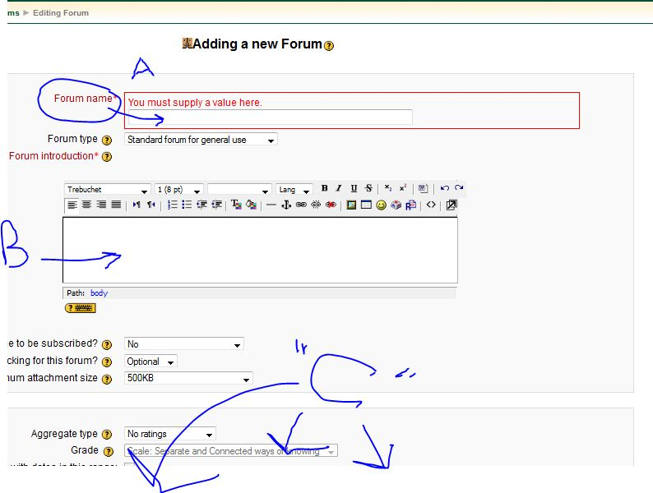

6 - at the bottom click on "Save and return to course"

The students can post, or they can cut and paste their work, or they can attach it as a document - but be sure to tell them in what format you want the material to be uploaded. .doc, .docx, .pdf etc.

You should now see something like this:

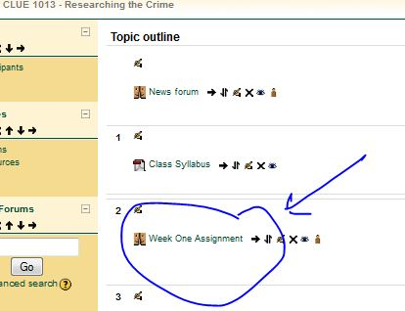

-----------------------------------------------------

When the student clicks on the name you gave it - they will see something like this:

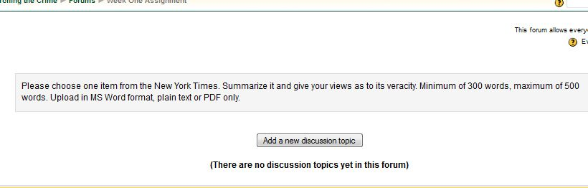

Here they must add a "Subject" and their name or whatever rules you gave them and then they can click "Browse" at the bottom to upload their review.
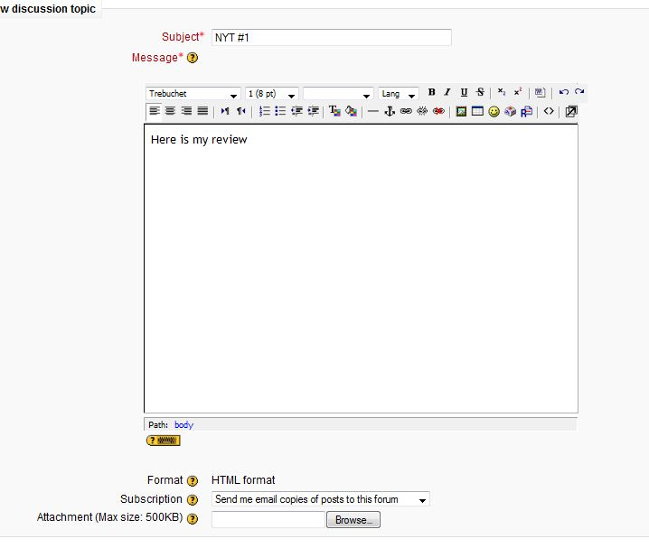

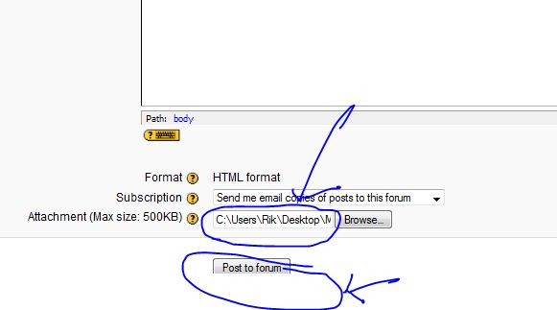

Once they click on Post, they are given 30 minutes to edit what the put there. It will then look like this:

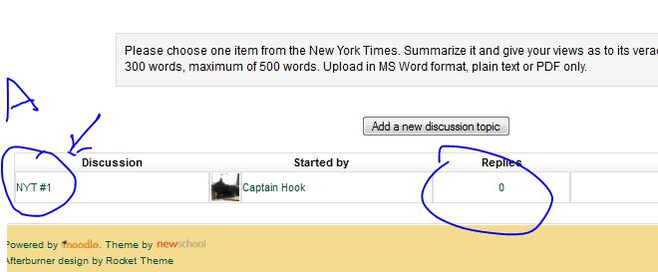

If they or you or another student click on the Name they gave it (in this case "NYT #1" they will see this screen where they can now download the file and read it.

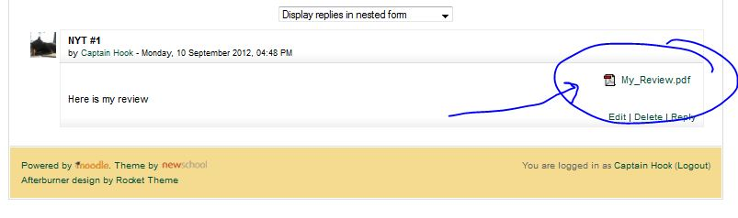

I hope that helps.

Rik

